Experiment No. 3

Title: Hall Effect

Aim: To find the Hall coefficient, RH of a given semiconductor and hence estimate the carrier density

Theory:

If a current carrying conductor placed in a perpendicular magnetic field, a potential

difference will generate in the conductor which is perpendicular to both magnetic field and current.

This phenomenon is called Hall Effect. In solid state physics, Hall effect is an important tool to

characterize the materials especially semiconductors. It directly determines both the sign and

density of charge carriers in a given sample.

Consider a rectangular conductor of thickness d kept in XY plane. An electric field is

applied in X-direction using a Current source, so that current I flow through the sample. If w is the

width of the sample and t is the thickness. Therefore, current density is given by

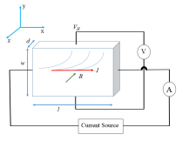

If the magnetic field is applied along negative z-axis, the Lorentz force moves the charge

carriers (say electrons) toward the y-direction. This results in accumulation of charge carriers at

the top edge of the sample. This set up a transverse electric field EH in the sample. This potential

difference along y-axis is known as Hall voltage VH and this effect is called Hall Effect.

A current is made to flow through the sample material and the voltage difference between

its top and bottom is measured using a volt-meter. When the applied magnetic field B=0, the

voltage difference will be ideally zero.

We know that a current flow in response to an applied electric field with its direction as

conventional and it is either due to the flow of holes in the direction of current or the movement

A current is made to flow through the sample material and the voltage difference between its top and bottom is measured using a volt-meter. When the applied magnetic field B=0, the voltage difference will be ideally zero. We know that a current flow in response to an applied electric field with its direction as conventional and it is either due to the flow of holes in the direction of current or the movement of electrons backward. In both cases, under the application of magnetic field the magnetic Lorentz force,

𝐹𝑚 = 𝑞(𝑣 × 𝐵)

causes the carriers to curve upwards. Since the charges cannot escape from the material, a vertical charge imbalance builds up. This charge imbalance produces an electric field which counteracts with the magnetic force and a steady state is established. The vertical electric field can be measured as a transverse voltage difference using a voltmeter. In steady state condition, the magnetic force is balanced by the electric force. Mathematically we can express it as,

𝑒𝐸 = 𝑒𝑣𝐵 (2)

where 'e' the electric charge, 'E' the hall electric field developed, 'B' the applied magnetic field and 'v' is the drift velocity of charge carriers.

The total number of charge carriers in the above sample is 𝑛𝐴𝑙, where 'n' is the number density (i.e. number of charge carriers per unit volume) of the charge carriers in the conductor of length ‘l’, breadth 'w' and thickness 'd ', the cross-sectional area 𝐴 = 𝑤𝑑 and thus 𝐴𝑙 is the volume. The total charge is thus 𝑛𝑒𝐴𝑙. If this total charge exits the sample in a time T, then the current is

𝑛𝑒𝐴𝑙 𝐿 . It means each charge carrier travels a distance l in a time T and hence has a velocity 𝑣 = . 𝑇 𝑇 Therefore, the current 'I ', defined as charge crossing a cross-section of the conductor in a time T, can be expressed as,

𝐼 = 𝑛𝑒𝐴𝑣 (3)

Using (1) and (2) the Hall voltage VH can be written as,

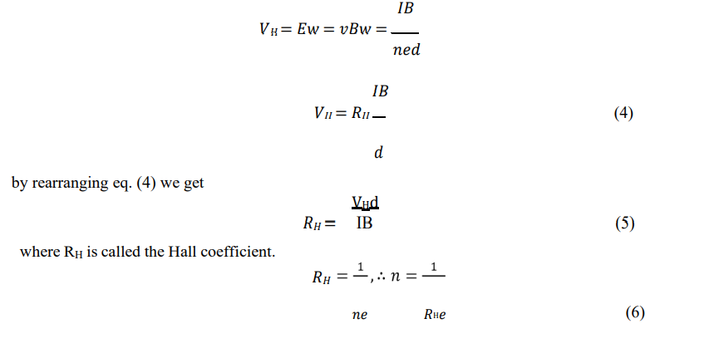

The value of 𝑅𝐻 is calculated from the measured parameters using eq. (5) and that of n from eq. (6).

Design of Experiment:

An electromagnet which can produce a magnetic field of B=1000Gauss in a gap of 30mm between the pole pieces is selected. An electromagnet (Fig. 2) consists of two solenoids with solid cylindrical iron cores such that the flat surfaces of the cylinders facing each other are North and South poles thus producing uniform field in the gap between the pole pieces. The sample is mounted on an insulating wooden sample holder. The sample holder is placed between the pole pieces such that the magnetic field lines (parallel to axis of the pole pieces shown by the red dashed line in Fig. 2) are perpendicular to the sample. A Hall probe is placed in the gap very near the sample such that its sensing element is also perpendicular to the magnetic field.

The electrical contacts for current and voltage measurements are made by pressure contacts. The pressure contacts are made of stainless-steel plates as shown in Fig. 3. The pressure can be varied by tightening the screws which hold the contacts down. Ideally, it is expected that the tips of the current contacts should be aligned in a straight line; similarly, voltage contacts should also be aligned. In practice, there is always a misalignment as shown schematically in Fig. 3 for the voltage contacts. This leads to a voltage V0 even in the absence of a magnetic field when a current is passed through the sample. This has to be subtracted out from the voltage obtained with field to obtain Hall voltage.

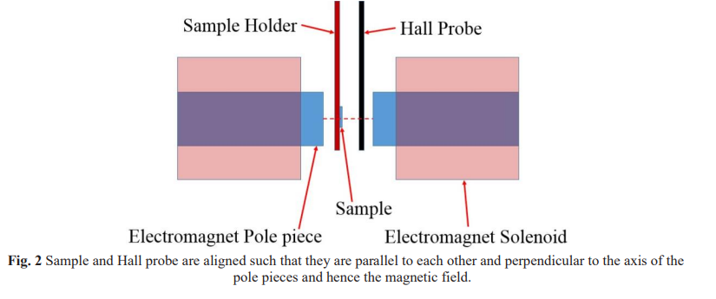

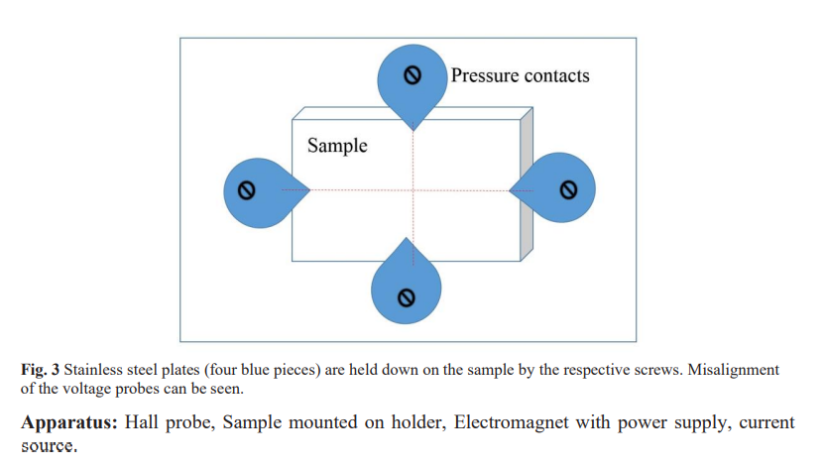

Procedure:

1. Adjust position of Hall probe to be perpendicular to the pole pieces of the electromagnets.

2. Switch on the electromagnet. Increase the current through the electromagnet and measure the magnetic field B using the Gaussmeter. Adjust B to the desired value (1000G).

3. Place the sample in pole pieces of the electromagnet such that it is perpendicular to the magnetic field. Keeping B constant, vary current I through the sample in suitable steps and note corresponding values of voltage V.

4. Switch off the electromagnet. Keep the sample away from electromagnet. Measure voltage V0 without field for the same current values as in step 3. Hall voltage VH = V-V0.

5. Plot VH versus I and find the slope m.

6. Find Hall coefficient RH= md/ B.

7. Also find charge carrier density 'n' using n=1/ RH e.

Observations:

1. Thickness of the probe (Given), d = 0.5 mm =0.5 * 10-3m

2. Constant magnetic field, B = 1000 Gauss =0.1Tesla

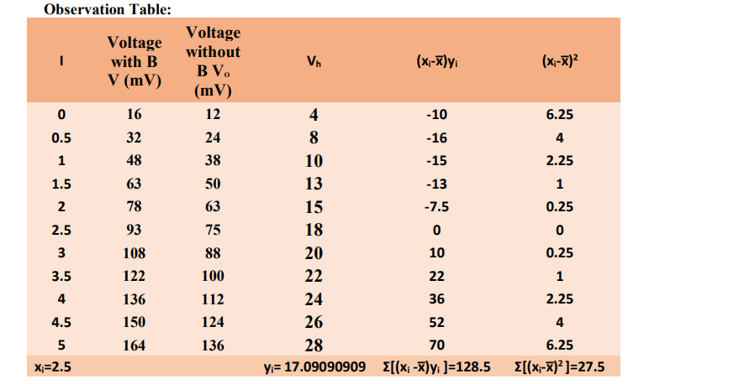

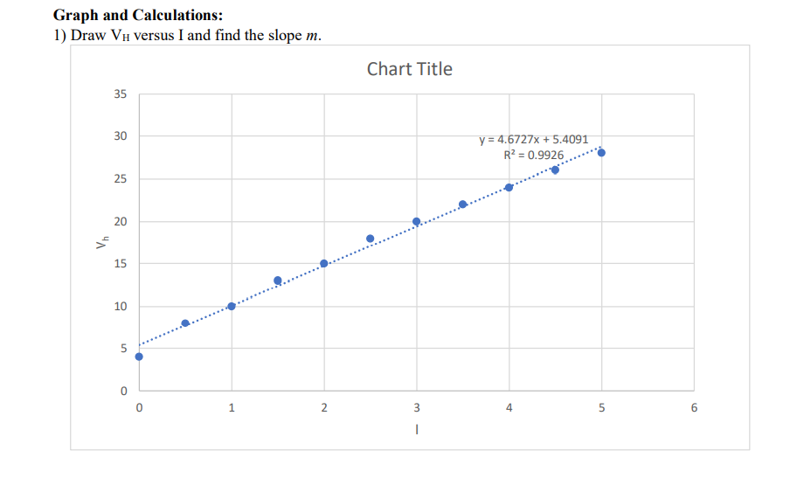

m=4.6727

c=5.4091

Rh= (4.6727*0.5 * 10^ (-3))/0.1=0.02336

n = 1 /𝑒Rh = 1/ (1.602 x 10^19 * 0.02336) = 26.7217*10^ (19)

2) Using the numerical method, outlined using an example below, to find the slope m.

Calculate

1. 𝑅𝐻= 𝑚𝑑/𝐵= (4.6727*0.5*10^(-3) )/0.1 = 0.02336
2. (ii) 𝑛 = 1 /𝑒Rh = 1/(1.602 x 10^(-19) * 0.02336) = 26.7217*10^(19)

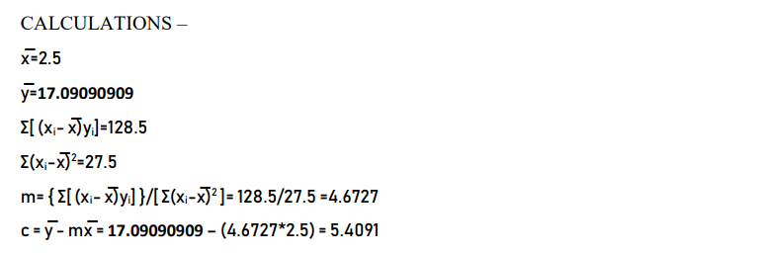

Results:

Hall Coefficient of the given material 𝑅𝐻=0.02336 𝑚3⁄𝐶

Charge carrier density of the given material 𝑛 =26.7217*10^(19) 𝑐𝑎𝑟𝑟𝑖𝑒𝑟𝑠⁄𝑚3

Conclusions: As long as the magnetic field and the current stayed below some threshold, there was a linear relationship between the voltage measured, and the current and B field applied

Questions:

1) Explain the working principle of a Magnetic encoder which detects rotational position information. **Magnetic rotary encoders rely on three main components: a disk, sensors, and a conditioning circuit. The disk is magnetized, with a number of poles around it. Sensors detect the change in magnetic field as the disk rotates and convert this information to a sine wave. The sensors can be Hall effect devices, which sense a change in voltage, or magneto resistive devices, which sense a change in magnetic field. The conditioning circuit interpolates the signal to produce the desired output.**

**The simplest magnetic encoder consists of a permanent magnet and a magnetic sensor. The permanent magnet is attached to the tip of a rotating body such as a motor shaft, and the magnetic sensor is fixed in a state where it is mounted on a PCB board at a position where it receives the magnetic field generated by the permanent magnet. When the permanent magnet attached to the motor shaft rotates, the direction of the magnetic field detected by the magnetic sensor changes, as a result the encoder detects the rotational position and speed of the motor shaft**

2) What precautions must be taken to

(i) minimize the errors in the data in this experiment (Hint: check if all the assumptions in the derivation of the formula are reproduced in the performance of the experiment)

**• The magnet power supply can furnish large currents at dangerous voltage levels; do not touch exposed magnet coil contacts.**

**• The oven gets hot.**

**• Turn on water before turning on magnet coil.**

**• Do not exceed magnet current of 10 A.**

**• Do not exceed Hall probe current of 0.4 A**

**• Do not exceed an oven temperature of 100°C .**

**• Do not leave the magnet current at a high setting for any length of time beyond the minimum needed for data acquisition.**

**• Do not bring floppy disks, magnetic cards, magnetic tape, prepaid cards, tickets, cathode ray tubes, etc., as they may damage the data in the magnetic recording media.**

**• Do not bring near electronic devices as they may affect the instrument and control panels, leading to accidents and malfunctions.**

**• Hall detection is also sensitive to stray magnetic fields.**

(ii) safeguard persons, materials and instrument while performing the experiment (Hint: (a) large magnetic field, (b) how fast the current through a solenoid can be increased or decreased (c) effect of magnetic field on electronics). What are the WHO guidelines for magnetic field human safety?

**• For occupational exposure, present limits are based on avoiding the sensations of vertigo and nausea induced by movement in**

**• a static magnetic field. The recommended limits are time-weighted average of 200 mT during the working day for**

**• occupational exposure, with a ceiling value of 2 T. A continuous exposure limit of 40 mT is given for the general public. Static**

**• magnetic fields affect implanted metallic devices such as pacemakers present inside the body, and this could have direct**

**• adverse health consequences. It is suggested that wearers of cardiac pacemakers, ferromagnetic implants and implanted**

**• electronic devices should avoid locations where the field exceeds 0.5 mT. Also, care should be taken to prevent hazards from**

**• metal objects being suddenly attracted to**

**• magnets in field exceeds 3 Mt**

3) How can the type of majority charge carrier be found out from the Hall effect experiment?

**If a current carrying conductor placed in a perpendicular magnetic field, a potential difference will generate in the conductor which is perpendicular to both magnetic field and current. This phenomenon is called Hall Effect. In solid state physics, Hall effect is an important tool to characterize the materials especially semiconductors. It directly determines both the sign and density of charge carriers in a given sample, and from it we can easily determine the type of majority charge carriers**